Mark York
Theme: History of Old Processors
Github link: https://github.com/myork01/project-101.git

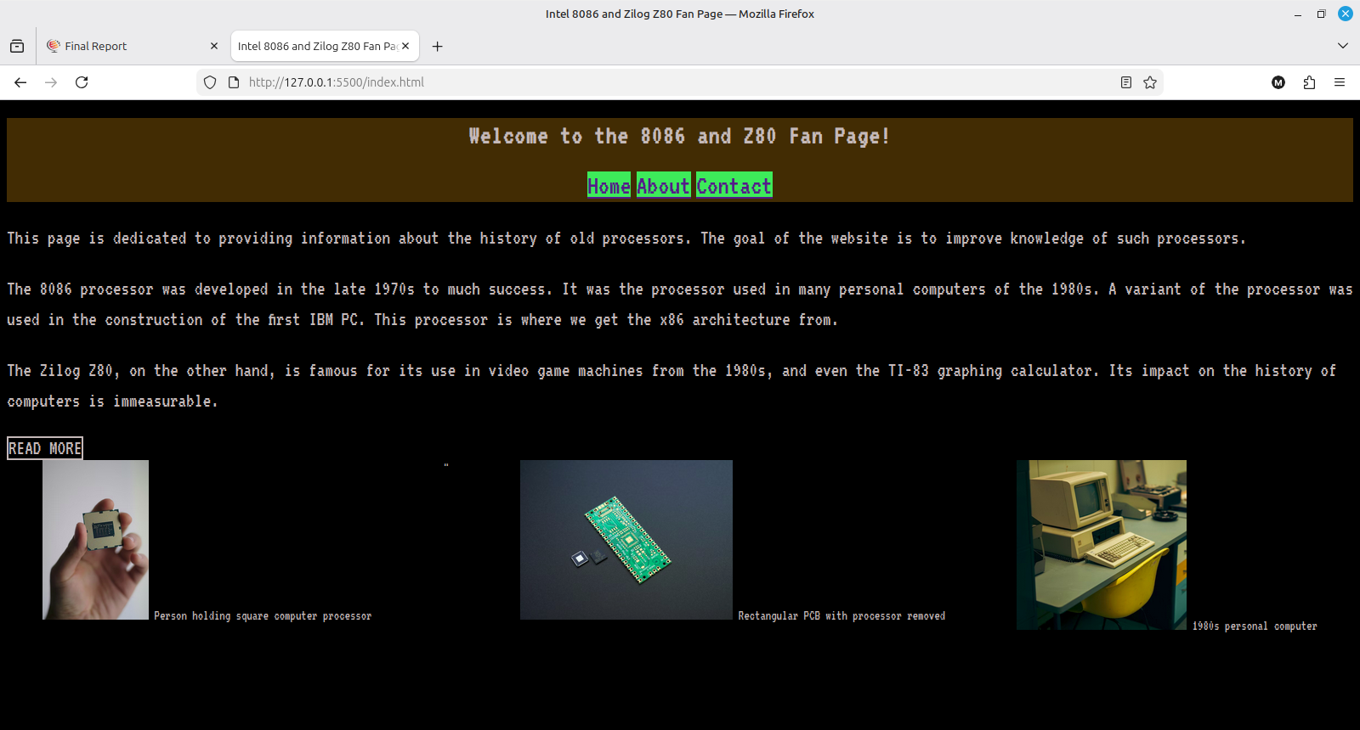

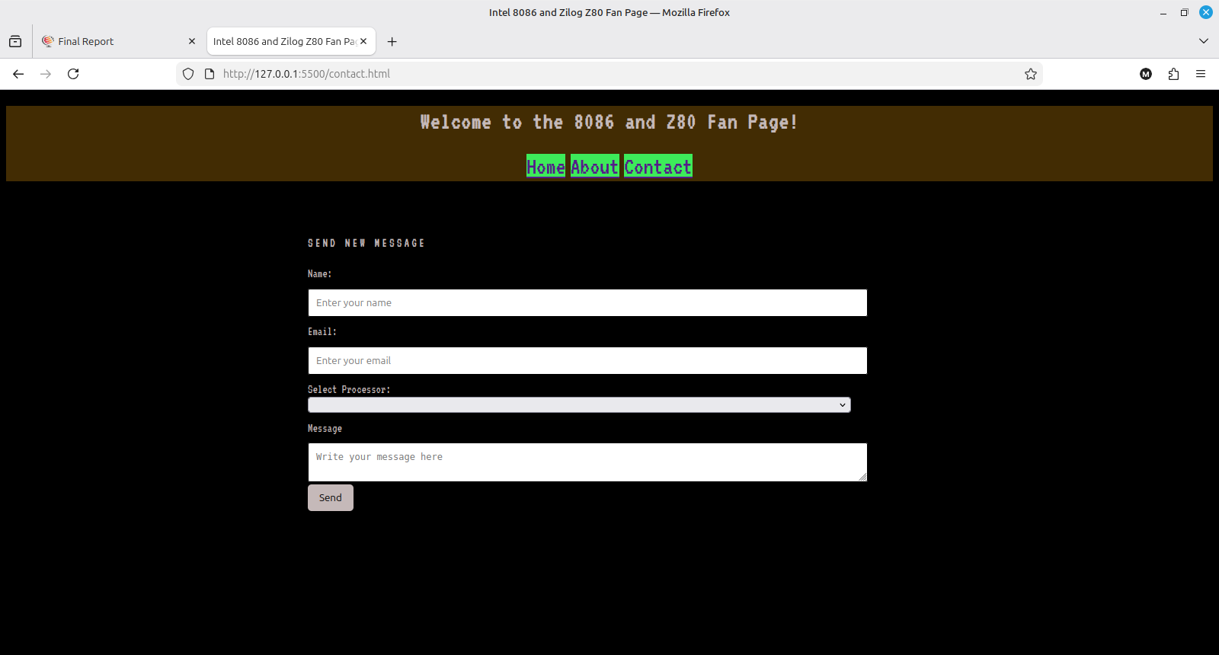
Summary of edits

Added Contact page
Added the following forms:
text entry
message area
dropdown box
Added "required" functionality to all forms except for the message
Added placeholders for all forms
Added "Send" button
Addd hover functionality to "Read More" ID

